What Invasion Means to Standard
Rui Oliveira
Standard is a very unique format. While the other major Constructed format, Extended, is known for not changing frequently, Standard works in exactly the opposite way. Not only does it change with every expansion, but one a year it loses a full block.

Standard, as of November 1
Legal Sets:
Classic (Sixth) Edition
Mercadian Masques
Nemesis
Prophecy
Invasion
Banned List:
There are no banned cards in Standard
A block is made by three expansions: a core expansion (often called a "standalone") and two small ones. A core expansion has about 330 cards and basic lands (for example Urza's Saga, Mercadian Masques and the most recent Invasion). The small expansions have about 140 cards and are related to a core expansion (for example: Prophecy and Nemesis are related to Mercadian Masques).
Standard is composed by the latest Classic Edition (currently the Sixth Edition but the Seventh is on the way) and up to two full blocks. That means that when a new core expansion comes out, Standard loses a full block and only gains a core expansion (the new one). This changes everything.
So next month when Invasion joins Standard, 616 cards will rotate out with Urza's block (330 from Urza's Saga, 143 from Urza's Legacy and another 143 from Urza's Destiny). If you take into account that the whole card pool for Standard is currently around 1432 cards (ignoring basic lands) it's easy to see how big a change we are facing.
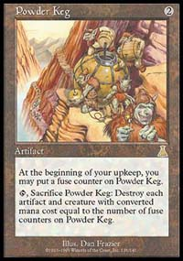
Standard will shrink from the above-mentioned 1432 to somewhere around 1146 cards. That is a big shift. Not only because of the sheer number of cards but also because of the general power of Urza's block. Cards that we took for granted will leave and we will have to find new ways to deal with the old problems. For example, Masticore and Powder Keg gave green, white and blue easy answers to creature control.
So we have to start from scratch. Or almost from scratch. We do have the Masques Block decks we used a couple of months ago as a starting point. We do know what Classic has to offer. With that in mind, most players are scavenging the Invasion spoiler looking for that elusive bomb that will grant an edge, if even for a little while.
The prospect of starting all over again draws different reactions from players. Some enjoy this time of uncertainty and constantly strive for the best deck while others feel totally lost without that fuzzy feeling of an established metagame.
Urza's Block is full of powerful cards that defined the core composition of the dominant decks in Standard. Some, like dreaded Replenish, were narrow cards that worked best in a specific deck. Other, like the omnipresent Masticore, were used in a huge number of decks for very different purposes.
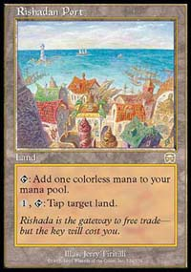
The main question when you want to start working is this: Should I adapt a known archetype or start something totally new? Last year, this question was easily answered as Masques Block expansions joined the card pool. Urza's Block was too powerful so players just looked at Masques for support unless there were obvious environment-breaking cards (Rishadan Port, Lin Sivvi). With Invasion, things are not so simple. Invasion looks, strangely, about as strong as Masques.
Where do players start? Do we start with the Masques block decks, and add Classic and Invasion? Or do we drop everything and try to puzzle cards together? While working from known decks can often give a head start in a good direction, starting from nothing can clear your mind and point you to something strong but unheralded.
Most metagames in Magic, at least most healthy metagames, can be broken down in three deck types: Beatdown, Control and Combo. They usually work literally like the proverbial Paper, Rock and Scissors. Beatdown overwhelms Control, which dominates Combo. Combo wins against Beatdown. This isn't always true, but it is a good general rule. It's important to observe how the block rotation impacted these three archetypes, as the shifts help decide which deck is going to be best. How did these three archetypes fare with Invasion?

Beatdown

When things slow down, the first to suffer is Beatdown...
Beatdown suffered a big blow. Its main representative, Stompy, is practically buried. Gone are the days of Cradles, Rancor and all those hyper-efficient creatures, like Pouncing Jaguar and Wild Dogs. On the other hand, Powder Keg and Masticore, the main foes of beatdown decks, are also gone. Standard has been such a fast environment since Tempest that the few last sets have made a strong point of slowing the tempo down. When things slow down, the first to suffer is Beatdown.
Masques was really bizarre as far as Beatdown is concerned. The best aggressive deck was Blue! Rebels, while a force to be reckoned with at the outset of the metagame, slowly faded away into the background. Invasion does help a bit. Gone, maybe forever, are the days of brutal first turn drops but if, like in Masques Block, turn three drops are still threatening enough, we might get some horde action once again.
Invasion seems eager to reward multicolor deck, as long as players choose "friendly" colors (colors that are adjacent in the Magic circle like red and green or blue and white). Beatdown is no exception is this matter: blue/black gets Sleeper's Robe, green/white gets Armadillo Cloak, black/red gets the excellent Blazing Specter and green/red has an aggressive split card in Assault/Battery.
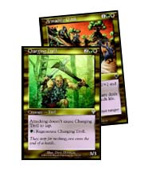
One thing an opponent should NEVER control
Blue/Black has great tools in all the Masques blue flyers and removal. Add Coastal Piracy, Sleeper's Robe and Fact or Fiction for some card advantage, toss in some removal and counters for the most troublesome cards and the deck should be set. Green/White is packed full of great creatures in the three or four mana zones: Blastoderm, Noble Panther, Chimeric Idol, Silt Crawler and a lot more. To improve the speed, Green's mana creatures can accelerate the mana curve, allowing players to cast big hitters earlier than expected. White also has some support cards in Seal of Cleansing and Parallax Wave. Armageddon is a powerful finisher, in this mana-hungry environment(taking advantage of your mana creatures). Armadillo Cloak looks really interesting: trample and +2/+2 is good in Beatdown and the Spirit Link thing will certainly help race rival speed decks. A Cloaked Charging Troll is a thing of sheer beauty.
Black/Red has to come out of the blocks flying or it will be in trouble. In a metagame full of dangerous enchantments, black/red will have a hard time surviving in a long game. Blazing Specter looks like a deck theme in itself and it may convince players to invest in this combination of colors. Regardless of that, black/red has to play a fast game. Green/Red is harder to call. The Kavu look interesting enough, but they may not form a cohesive deck. Maybe the best possible interaction is using green's superior big creatures and red's burn to clear the way. This is a very classic strategy.
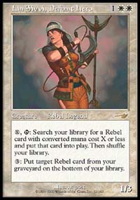
Rebels on the mend?
Should we really abandon monocolor decks? Rebel was doing all right. Monowhite seems deep enough to support it. Sure, Massacre is still around, but the real trouble with rebel decks in the old metagame was the inability to deal with Replenish or Hermit in a timely fashion. There weren't any new Rebels in Invasion, but the slowdown gives the deck some extra turns to work with. Blue Skies also got some extra tools and could probably still stand on its own two feet (or wings).

Control
Control is hard to pinpoint because control usually sets its configurations last. The goal in Beatdown is outracing your opponent and the goal in Combo is setting up a winning situation (normally all in the same turn). The goal in Control is to stop these things from happening. You can do it by blowing up their lands (land destruction decks), countering their spells (permission decks) or by discard (black disruption decks).
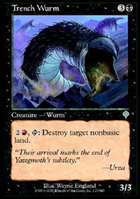
Dwarven Miner gets bigger, meaner
Land destruction seems like a perfect option right now. People are switching to multicolor decks, so blowing up land gets better if you know which colors to go for first. Green, red and black are the colors of land kill and they all got new stuff. Black gets the amazing Trench Wurm, which can wreck havoc on non-basic land and is not too shabby as a creature, either. Frenzied Tilling may fill out the high end of the curve in some Green/Red LD decks. Blue does get a good answer in Teferi's Response, but I still see LD decks as a good option, either in targeted form or global removal like the mighty Armageddon. Between G/B and R/G you have a good set of options to work with. Red/Green also has the most cool control card combination as far as I'm concerned: Meteor Storm + multiple Squees.
Another option is using a few land destruction spells (mostly global ones) to slow your opponent and some generic spells (like Creeping Mold or Pillage) as a way to answer all types of threats. Creatures should not be a problem for either red or black and green should provide all the pressure you could ever need. Generic control decks are hard to build and must constantly adapt to changes in the metagame. They normally only do well when they have either amazing speed, for example the Angry Hermit family, or incredibly effective tools, like Wildfire.
Permission decks don't know what to make of the rotation. They took a big hit when they lost Masticore, Powder Keg and Morphling. Losing the first two left permission without a direct answer to creature control and the second one left them without a finisher. But Invasion came to the rescue. No, permission didn't get another Morphling, but the solution is the same as in Beatdown: find some room for another color.
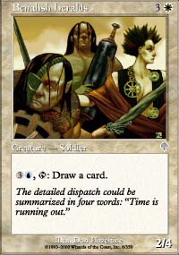
Book of the future?
Blue/white and blue/black got some first rate counters: Absorb and Undermine. Both counters are very strong, with their rarity being the only noticeable downside. Opt and Fact or Fiction give permission all the card drawing it needs. If you choose White, you have will have top notch removal, with Wrath of God and Disenchant. I'm also sure the Benalish Heralds will find their way into some decks, as a creature with a built-in Jayemdaye Tome effect. If you choose black, you still get good removal (including Spite/Malice) and some interesting discard to help out. Blue will lose its big finisher Morphling but there are still good options: Spiketail Hatchling, Blinding Angel, Alexi, Mageta and much more.
With most of its speed knocked out, black gets a few new discarding options. Not only is Ravenous Rats back, but Blazing Specter has raised many eyebrows. Coupled with Stupor and Chilling Apparition, we may have the genesis of a Black discard comeback. The discard looks good enough and we all know that black has enough removal to control the table. All you need to do is add a second color to help out with Black greatest weakness: enchantments and artifacts.

Combo

Are there any combo pieces hiding in those huge Invasion spoilers?
Combo is the hardest call. Replenish and Bargain are obviously gone, losing their key cards, but who knows what looms ahead? Combo decks are born from two things: abusable or broken cards and first class searchers. You need some combination of cards to abuse, but you also need a way to find those cards fast or your opponent will be ready for it.
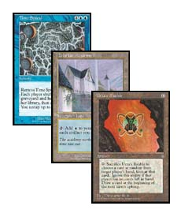
Finding broken card combinations is tough. First you need to find the matching pieces. Some combos revolve around a small number of core cards (Time Spiral + Tolarian Academy + abundant cheap artifacts) while others rely on an intricate card interaction (see the Bargain or ProsBloom setups). The bottom line is: are there any combo pieces hiding in those huge Invasion spoilers? I don't think so. R&D was so careful after Urza's combo-rich environment, that I can't find a solid combo card. Then again, sometimes seemingly ineffective cards turn into big troublemakers when coupled with other cards.
Searchers are a very different story. Fact or Fiction is awesome. I didn't believe all the hype until I tried it but once I did it just blew me away. This card is amazing and will surely become a staple in any deck with Blue, even justifying some splashes in other decks. Desperate Research also looks very good and Sterling Grove might see some play if enchantments continue as rulers of the metagame. We already have the Mirage Tutors in Classic and Rhystic Tutor, so as far as searchers are concerned there are plenty to choose from.
In the end, we have a lot of work ahead of us and we also have many things to discuss. Talking about Magic is almost as good as playing it. I hope this new Standard environment will keep up the interesting metagame shifts of Masques block.

